**Color scale**

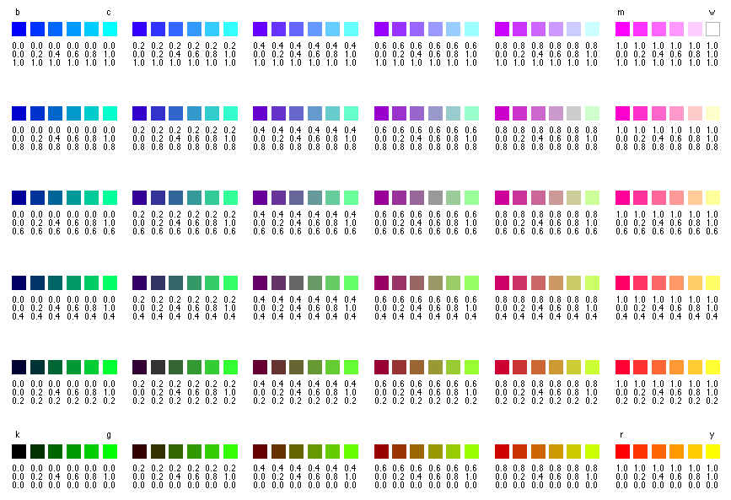

**Grey scale**

